C++ SCIENTIFIC LIBRARIES

Summary

 | OS | Licence | Language | Handy | Complete | Lin. Alg | Optim | Rand Nr. | Documentation
GSL | Win/Unix | GPL | C/C++°/  Python! | Yes no | Yes yes | Yes yes | yes | Yes yes | good
Scythe | Win/Unix | GPL | C++ | Yes yes | Yes no | Yes no | yes | Yes | bad
Newmat | Win/Unix | ? | C++ | Yes yes | Yes no | Yes | yes | yes* | medium
MTL | Win/Unix | ? | C++ | no | Yes no | Yes yes | no | no | good

Unix means Linux and Mac

° Using GSLWrap
*using NewRan

GSL is best for routines quality and completeness (complex numbers,...), a little unhandy
Schyte is an alternative, not so complete but more handy.
A good compromise would be to use an handy one able to call well founded libraries for the most critical tasks (Lapack for linear algebra), GSL for random numbers and optimization and so on.

Remark: had very difficult browsing on Schyte website, so there might be some more good documentation I've not found.

Gnu Scientific Library

Language: C (C++ with GSLWrap)

Capabilities
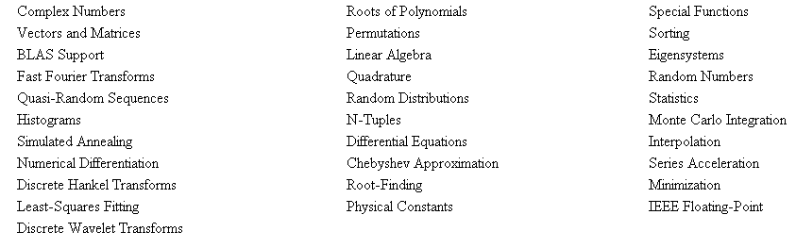

Platform
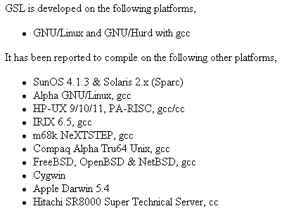

Licence
GSL is distributed under the terms of the GNU General Public License (GPL)

Scythe

Language: C++

Capabilities
The Scythe Statistical Library is an open source C++ library for statistical computation written by Andrew D. Martin (Washington University), Kevin M. Quinn (Harvard University), and Daniel Pemstein (University of Illinois). It includes a suite of matrix manipulation functions, a suite of random number generators (useful for Markov chain Monte Carlo methods), and a suite of numerical optimizers (useful for maximum likelihood estimation). Programs written using Scythe are many orders of magnitude faster than those written in commonly used interpreted languages, such as R, GAUSS, Matlab, and Ox

Platform
tested on Linux and MacOS X.
can be compiled on any system with the GNU GCC compiler (and perhaps with other C++ compilers).

Licence

GNU General Public License

Newmat

Language: C++

Capabilities
It supports matrix types: Matrix (rectangular matrix); UpperTriangularMatrix; LowerTriangularMatrix; DiagonalMatrix; SymmetricMatrix; BandMatrix; UpperBandMatrix; LowerBandMatrix; SymmetricBandMatrix; IdentityMatrix; RowVector; ColumnVector.

Only one element type (float or double) is supported.

The library includes the operations *, +, -, *=, +=, -=, Kronecker product, Schur product, concatenation, inverse, transpose, conversion between types, submatrix, determinant, Cholesky decomposition, QR triangularisation, singular value decomposition, eigenvalues of a symmetric matrix, sorting, fast Fourier and trig. transforms, printing and an interface with Numerical Recipes in C.

It is intended for matrices in the range 10 x 10 to the maximum size your machine will accommodate in a single array. The package works for very small matrices but becomes rather inefficient.

A lazy evaluation approach to evaluating matrix expressions is used to improve efficiency and reduce use of temporary storage.

Platform
I have tested the library with Borland (Builder 5,6), Microsoft (VC++ 6,7,8), Open Watcom (1.4), Intel 9 on a PC; Gnu G++ (3.3), Sun C++ on a Sun and Gnu G++ (3.4,4,4.1) and Intel 9 C++ under Linux.

Licence
???

Matrix Template Library

Language: C++

Capabilities

Matrix Types
The use of generic programming enables a large variety of matrix types to be supported (i.e., for each algorithm) in the MTL with many fewer lines of code. The matrix types supported include:
Dense (contiguous)
Compressed
Banded
Packed
Diagonal, Tridiagonal
Triangle
Envelope
Symmetric
Array of pointers to std::vector, list, set, etc.

Arbitrary types can be used for matrix elements (the requirements that must be satisfied by the type will depend on the algorithms in which they will be used). Common types that can be used include
float
double
complex<float>
complex<double>
Algorithms / Linear Algebra Operations

The algorithmic abstractions that were developed for MTL were motivated to a large extent by the mathematical structures underlying numerical linear algebra. That is, there are well-defined properties that give rise to the mathematical structures known as linear algebras (as well as Banach spaces, Hilbert spaces, etc.).

Remarkably, there are a very small number of algorithms required to represent the mathematical structures typically associated with numerical linear algebra:

Platform: Unix, Windows

Licence: ???

